Assingment-2

Name: G.SIDDHARTHA REDDY
Roll_no:2503A52368 Batch_no:13

Task 1: Statistical Summary for Survey Data
Prompt: generate a Python function that reads a list of numbers and calculates the mean, minimum, and maximum values.

Code:
def calculate_statistics(numbers):
if not numbers:
return None, None, None # Return None for mean, min, and max if the list is empty

mean_value = sum(numbers) / len(numbers) min_value = min(numbers)
max_value = max(numbers)

return mean_value, min_value, max_value #exapmple usage:
numbers = [10, 20, 30, 40, 50]
mean, minimum, maximum = calculate_statistics(numbers) print(f"Mean: {mean}, Minimum: {minimum}, Maximum: {maximum}")

output:
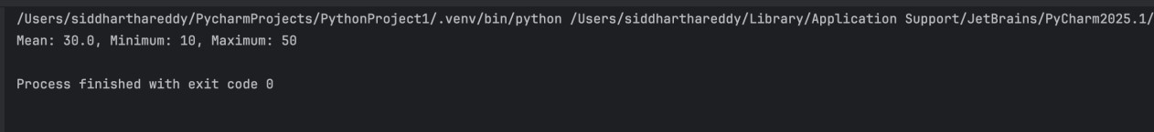

Task 2: Armstrong Number – AI Comparison
Prompt: Generate an Armstrong number checker using Given a number, check if it is an Armstrong number or not. Compare their outputs, logic style, and clarity.

Code:
def is_armstrong_number(n):
# Convert the number to a string to easily iterate over each digit digits = str(n)
num_digits = len(digits)

# Calculate the sum of each digit raised to the power of the number of digits armstrong_sum = sum(int(digit) ** num_digits for digit in digits)

# Check if the calculated sum is equal to the original number return armstrong_sum == n
# Example usage:
number = 153
if is_armstrong_number(number): print(f"{number} is an Armstrong
number.") else:
print(f"{number} is not an Armstrong number.")

output:
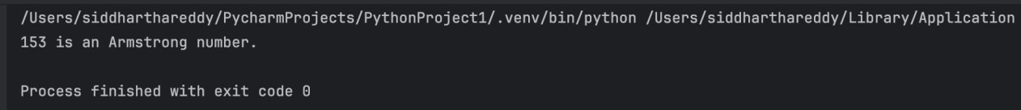

Task 3: Leap Year Validation Using Cursor AI
Prompt: generate a Python program that checks whether a given year is a leap year.also give two different methods to check for leap year and compare their
outputs, logic style, and clarity.

Code:
# Method 1: Using the standard leap year rules def is_leap_year_method1(year):
if (year % 4 == 0 and year % 100 != 0) or (year % 400 == 0): return True
else:
return False # Example usage:
year = 2020
if is_leap_year_method1(year): print(f"{year} is a leap year.")
else:
print(f"{year} is not a leap year.")

# Method 2: Using a more concise approach def
is_leap_year_method2(year):
return year % 4 == 0 and (year % 100 != 0 or year % 400
== 0) # Example usage:
year = 2021
if is_leap_year_method2(year): print(f"{year} is a leap year.")
else:
print(f"{year} is not a leap year.")

#example usage:
year = 2024
if is_leap_year_method1(year) == is_leap_year_method2(year): print(f"Both methods agree that {year} is a leap year:
{is_leap_year_method1(year)}")

output:

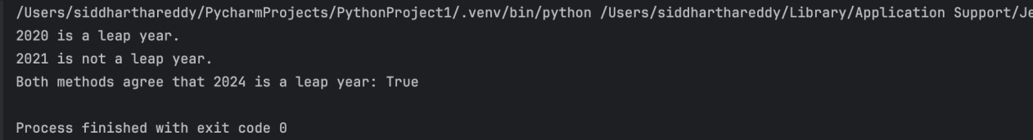

Task 4: Student Logic (Odd/Even Sum)
Prompt: Write a Python program that calculates the sum of odd and even numbers in a tuple.

Code:
def sum_odd_even(numbers):
odd_sum = sum(x for x in numbers if x % 2 != 0) even_sum = sum(x for x in numbers if x % 2 == 0) return odd_sum, even_sum

# Example usage:
tuple_numbers = (1, 2, 3, 4, 5, 6, 7, 8, 9, 10)
odd_total, even_total = sum_odd_even(tuple_numbers) print(f"Sum of odd numbers: {odd_total}")
print(f"Sum of even numbers: {even_total}")

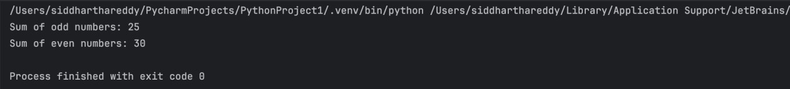
output:

